ARCHITURAL DIGEST
WEB-EXCLUSIVE HOME TOUR

Step Inside a Mesmerizing Tribeca Penthouse
The home features expansive decks and impressive views
By Ariel Foxman
Photography by Ty Cole
September 27, 2021
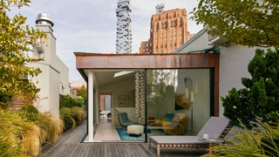

Manhattan apartments can be all sorts of magic, yet there are some real estate unicorns that are still hard to come by. A classic Tribeca loft with tons of outdoor space would definitely be one of them. Elusive nonetheless, it was that sort of setup that intrigued entrepreneurs Ellen and Michael Diamant. The couple, who had recently sold their wildly successful better-baby-goods company, Skip Hop, to Carters and whose child, Spencer, was heading off to college, were on the hunt for something new. It was time to find an apartment that spoke directly to how they wanted to live their lives now—something sexy yet cozy, something quintessentially New York City but at the same time transportive.
“We wanted that loft feeling—to shift our lives from little rooms to entertaining space,” explains Ellen. “We were looking and looking and looking, and we found that there were either new developments where everything had been chosen for you or these huge places where you’d have to start from scratch and knock down to the studs.”
The couple opted for the latter, buying a penthouse structure at the top of a Tribeca building that had been the Philadelphia Cream Cheese cold storage warehouse back in the 1920s. “It was a wreck,” Ellen adds. “The building had been developed in the ’90s, but the previous owners never got to fixing up the loft.”
The couple enlisted a team of dreamers and doers to design, build, and decorate their beach-house apartment in the sky. “We met Matthew Baird [of Baird Architects] and were sold on the whole feeling of old meets new: modernizing the downstairs level while embracing the history. And then upstairs the concept would be a super-contemporary indoor-outdoor. An old loft building with a modern apartment,” she concludes
RKLA Studio Landscape Architecture dreamed up expansive and luxurious outdoor living areas, while Roger Miller Gardens composed just the right orchestration of lush plants and grasses to transform the patio into an urban paradise.
As for interior design, the Diamants worked with Joan and Jayne Michaels, the sisters behind 2Michaels. “This was our third project with them,” says Ellen. “We had collaborated on our Flatiron apartment and a small cottage we have on the water in Sag Harbor. I love that they’re funny and that they don’t want to do designs that feel like a time capsule. They love mixing old and new.”
Ellen continues: “They were so interesting to work with. Part of their whole style, their whole process, is organic. With the architecture being so structured—and there are so many rules and permits in New York City—it was fun, then, to finish off the place by putting things together and just seeing how they flowed.” So much fun that the couple had opted to furnish their new home entirely from scratch. Says Joan, “They didn’t keep one thing from their old apartment.” Jayne chimes in. “Yes, one thing: a Knoll console.”
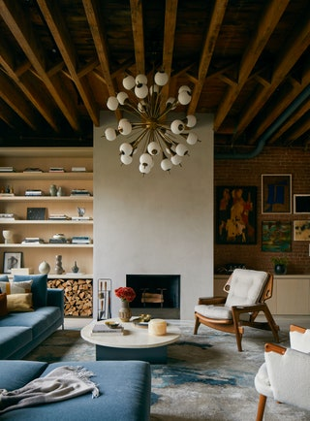

Joan and Jayne Michaels were absolutely convinced that the 1960s Italian Murano Sputnik chandelier would make the perfect centerpiece for the family’s vast living room area. Ellen Diamant was not so sure. “It’s 48 inches in diameter,” says Jayne. “Ellen thought it was going to be too big. I kept saying it’s going to fit once it’s in a loft setting. We even had a mock-up of this beach ball in the same dimensions to show her. Now we all agree that, yes, this is it.” Baird and team had decided to showcase the building’s original ceiling joists and brick walls, so the designers worked with neutral and rich hues to ensure that the space remained warm and inviting. A sofa by B&B Italiacovered in Holly Hunt fabric, as well as a Sergio Rodrigues Benjamin lounge armchair from Espasso, flank a travertine Isla coffee table by Egg Collective. Adds Joan, “In the previous apartment, Michael wasn’t really involved. So he really wanted to put his stamp on this place: He wanted a real masculine chair, with character. We looked high and low and we found this Sergio Rodrigues, and it was just it.”

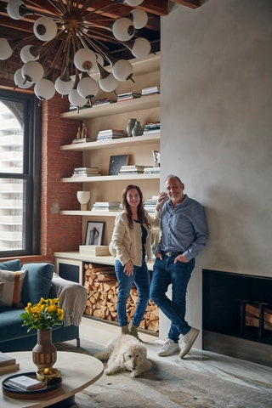

Entrepreneurs Ellen and Michael Diamant with their labradoodle, Charlie, in the living room of their Tribeca penthouse apartment. The couple’s collection of books and pottery sits atop shelves created by Wolski Wood Works.

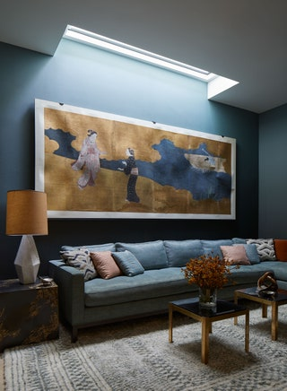
The Michaelses had created a cozy yet elegant den space in a previous property for the Diamants—and the couple wanted something similar in their new pad. “It feels like a womb,” says Jayne of this room. A mounted Edo-period Japanese screen from Lawton Mull at Incollect sets a decidedly sophisticated and soothing tone. “We looked at hundreds and hundreds and hundreds of Japanese screens, and they’re all very traditional,” says Jane. “But this one had almost a modern movement with the two women. Something contemporary.” An expansive Climate sectional sofa by Dune covered in Kerry Joyce Metro fabric in Peacock is paired with a couple of Caisson brass tables by Blend Interiors. A Warp table lamp by John Sheppard, along with a skylight, helps to further set the mood.
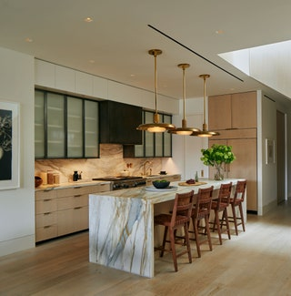

The Diamants absolutely love to entertain, so a large and functional kitchen is key. Woven-leather-and-walnut counter stools designed by Mel Smilow from Suite NY pull up to an island by New York Stone. Brass Oscar pendants by Roman and Williams Guild make for a welcoming stay-a-while atmosphere. The custom cabinetry is by Nico Juarez, while cabinetry glass is by Bendheim. Opposite the kitchen is an oak staircase that leads directly to the glass penthouse.
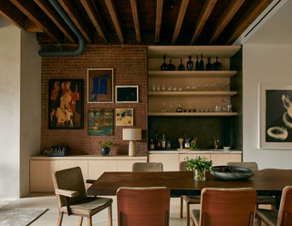
“They are very social people, and they’re wonderful hosts,” say the Michaelses of their clients. “When they give a party, they really go all out.” An enormous walnut-slab dining table by Robert Pluhowski anchors the dining area in the apartment’s largest, most loft-like, space. The table seats 10 (dining chairs are by Carlos Motta for Espasso), so there’s no need for a kids’ table come this holiday season. A custom steel bar with sink by Nico Juarez is outfitted with a handblown gray glass collection by Joe Cariati, clear barware and decanters from Crate and Barrel, and other elements. Artwork from Jorge Fick, Richard Serra, Orit Raff, and others is on display. A vintage Macintosh tube amp—one of Michael’s treasures—has a place of honor atop the built-in sideboard.
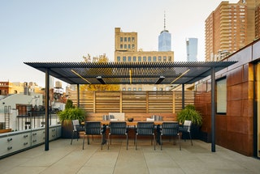
One of two distinct rooftop entertaining areas, the outdoor dining pergola, on the east side, has been a godsend for the Diamants during the pandemic. A teak dining table by Rob Pluhowski and a half-dozen dining chairs sit atop a limestone floor. A glass railing opens up to expansive views of the Tribeca neighborhood. The patio also boasts a full stainless-steel outdoor kitchen, complete with a grill, a basaltic-stone workshop area, a refrigerator, and an ice maker.

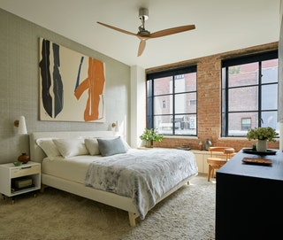

For the couple’s retreat, the architects carved out a luxurious bedroom suite at the end of a long hallway. To honor the loft’s history, they installed Crittall steel casement windows, evocative of those used in the 1920s, when the building was originally built. The bed is covered in Maharampressed linen and dressed in Frette bedding and a custom gray Rex throw by Dualoy. An Abstract Expressionist painting by Jack Roth adds energy to the space. A chair by Charlotte Perriand for Cassina is complemented by Boffi’s Air ceiling fan, both in golden caramel.

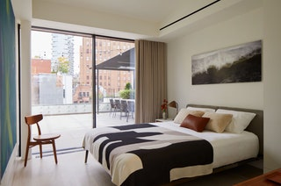

To the right of the penthouse stairs is a tidy bedroom suite, intended for the owners’ adult son or other overnight guests. Don’t make yourself too comfortable, though: The Pescador chair from Espasso is three-legged. “It’s really great as a sculpture, just to have in the bedroom,” says Joan. A Lifesteel bed from Flexform is dressed with Frette bedding and a custom throw by Judy Ross Textiles. The Break 22, a dye sublimation on aluminum photograph by Hamptons-based artist Jane Martin, brings an element of the beach to the bedroom.

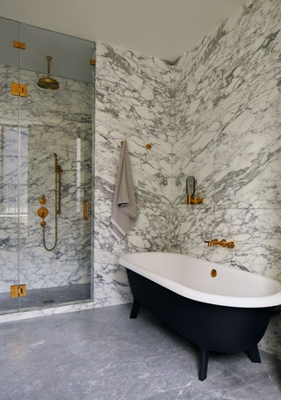
The architects worked overtime to perfect the primary bathroom’s book-matched marble, to optimal effect. A charcoal gray Ottocento bathtub by Agape and brass faucets and fixtures from Waterworks can also be seen.

